On Boarding Screen – After clicking Agree you will be redirected into our uPortal360 Contact Information page.
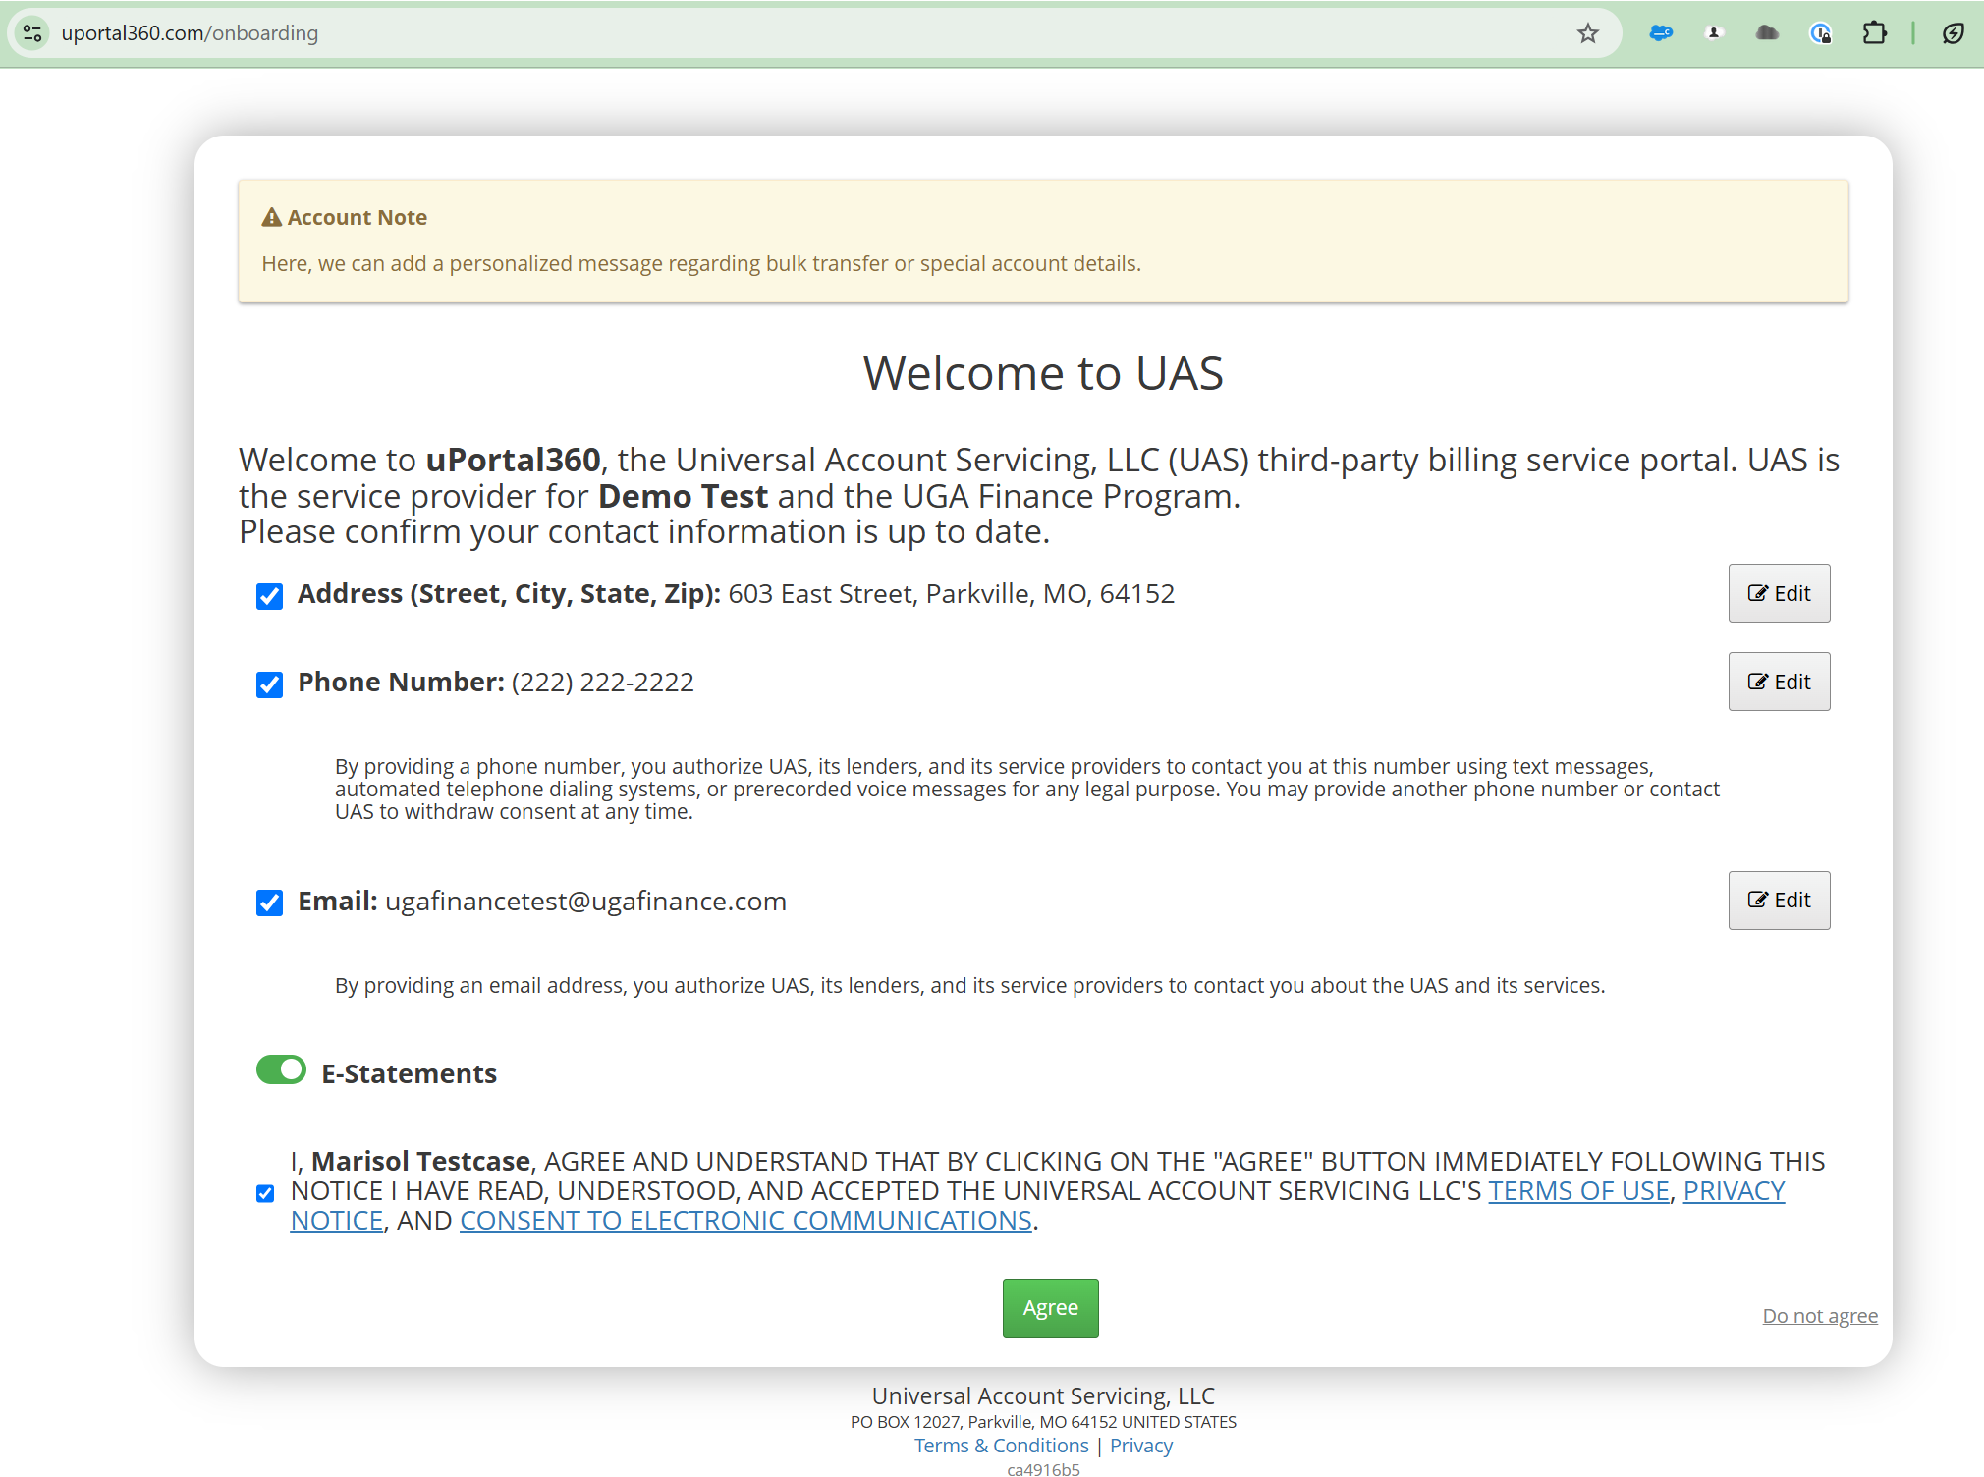
Below is the Onboarding Screen after clicking “Agree” button at the bottom of the screen without checking box to agree to the Terms of Use, Privacy Notice and Consent to Electronic Communications.
